**DATE: 24 AUG,2023**  
**TASK 1 COHORT**

**NAME: SONAM KUMARI**

**ENROLLMENT NO. : 13201172022**

**BATCH: CSE-AI 2ND YEAR**

**CODE:**

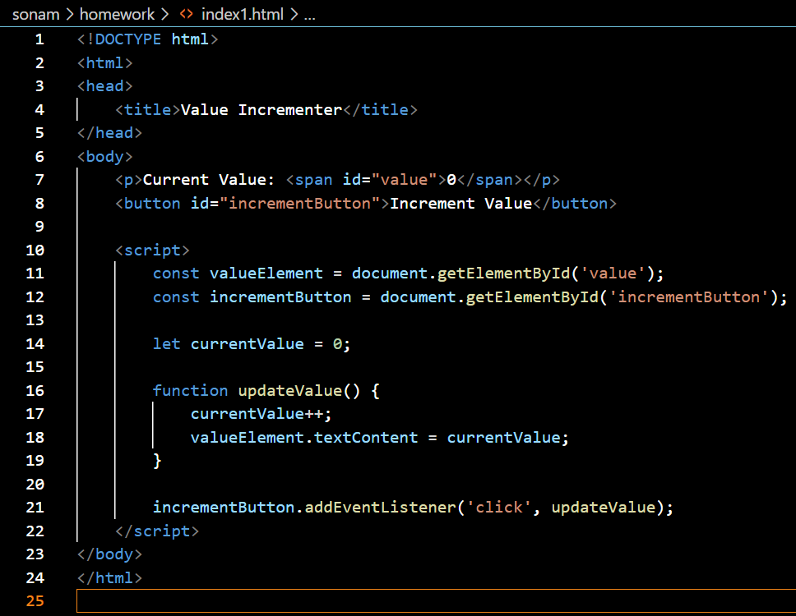

**OUTPUT:**

